English
Class: 1
Week 10
1.11.2020 – 7.11.2020

Look at the letter a and letter b. Listen to the word. Say the word. Write the letters.
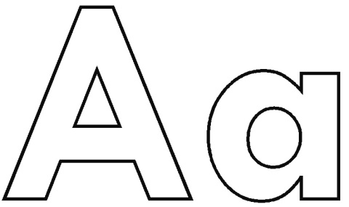  A is pronounced as ಆ್ಯ | 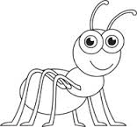  Apple  ant
B is pronounced as ಬ್ | 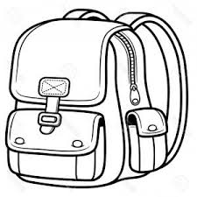  bag  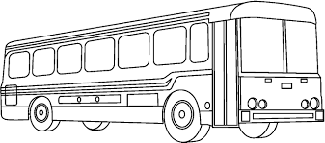  bus

Look at the picture. Listen to the word in the Week 10 audio. Draw a picture that relates to the word.
ಚಿತ್ರ ನೋಡು. 10ನೇ ವಾರದ ಆಡಿಯೋದಲ್ಲಿ ಪದವನ್ನು ಹೇಗೆ ಹೇಳುವುದೆಂದು ಕೇಳಿಸಿಕೊ. ಆ ಪದಕ್ಕೆ ಸಂಬಂಧಿಸಿದ ಚಿತ್ರ ಬರೆ.
Picture | Word | Draw a picture
 | girl
 | boy
 | house
 | straw
 | brick
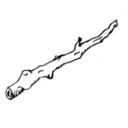 | stick
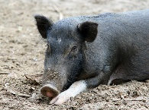 | pig
 | wolf

