**English**

**Name ______________**

**Week 16**

**Class: 1**

**See the picture. Say the word. Fill in the missing letter of the word.**

|  |  |  |  |
| --- | --- | --- | --- |
| C:\Documents and Settings\Admin\Desktop\A-Z NEW\apple.jpg | ____ pple | C:\Documents and Settings\Admin\Desktop\A-Z NEW\bag.jpg | ____ ag |
| C:\Documents and Settings\Admin\Desktop\A-Z NEW\CAT.gif | ____ at | C:\Documents and Settings\Admin\Desktop\A-Z NEW\DOG.png | ____ og |
| Image result for egg BLACK AND WHITE IMAGES | ____ ggs | C:\Documents and Settings\Admin\Desktop\A-Z NEW\fish.png | ____ ish |
| C:\Documents and Settings\Admin\Desktop\A-Z NEW\black-iron-gate-isolated-white-41856775.jpg | ____ ate |  | ____ en |
|  | ____ce cream | Jug Coloring Page drawing free image | ____ ug |
|  | ____ ey |  | ____ ight |

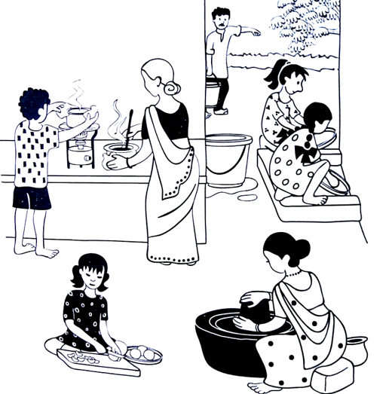

This is Kamala’s house. This is her family. Everyone is busy working this morning.

Kamala’s mother is making chutney.

Her father is bringing water.

Her brother is cooking rice.

Her sisters are washing plates.

Her grandmother is making sambar.

Do you know what Kamala is doing? She is cutting tomatoes.

Show this picture to your mother or father or friend. Tell them what everyone is doing in this picture.

**Match capital letters with small letters. Check if it is correct. Practice writing both.**



|  |  |  |  |  |  |
| --- | --- | --- | --- | --- | --- |
| **A** |  | **b** |  | **Aa** |  |
| **B** |  | **c** |  | **Bb** |  |
| **C** |  | **e** |  | **Cc** |  |
| **D** |  | **g** |  | **Dd** |  |
| **E** |  | **h** |  | **Ee** |  |
| **F** |  | **a** |  | **Ff** |  |
| **G** |  | **j** |  | **Gg** |  |
| **H** |  | **d** |  | **Hh** |  |
| **I** |  | **k** |  | **Ii** |  |
| **J** |  | **f** |  | **Jj** |  |
| **K** |  | **l** |  | **Kk** |  |
| **L** |  | **i** |  | **Ll** |  |

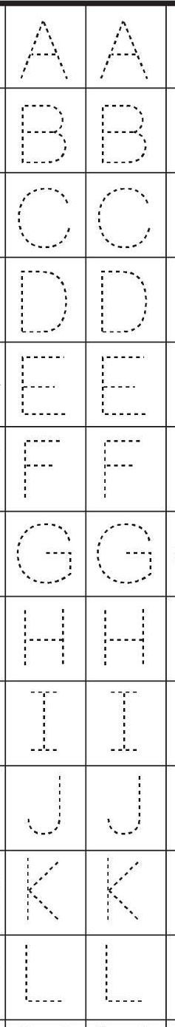**Practice writing these letters. Practice 2 lines every day.**

