MATHEMATICS
Class: 1
Topic: Shapes Topic 13
- Match the shapes
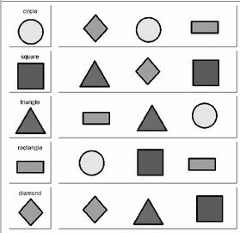
2)Let’s colour.
3) Do questions from textbook page no: 15, 16, 17.
4)Colour Blue Yellow Green Red

5)Join dots
