MATHEMATICS
Class: 1
Topic: Top Bottom: In On Under: Near Far: Under Above chapter 14
Top and Bottom (ಮೇಲೆ ಮತ್ತು ಕೆಳಗೆ)

1) Where is the ? Circle top or bottom.

2) Paste objects on shelf (check paper cover)
TOP: Clothes And Fruits (ಬಟ್ಟೆ ಮತ್ತು ಹಣ್ಣುಗಳು)
BOTTTOM: Shoes and Toys (ಬೂಟುಗಳು ಮತ್ತು ಆಟಿಕೆಗಳು)

In, On and Under (ಒಳಗೆ: ಮೇಲೆ: ಅಡಿಯಲ್ಲಿ)

3)Tick the correct
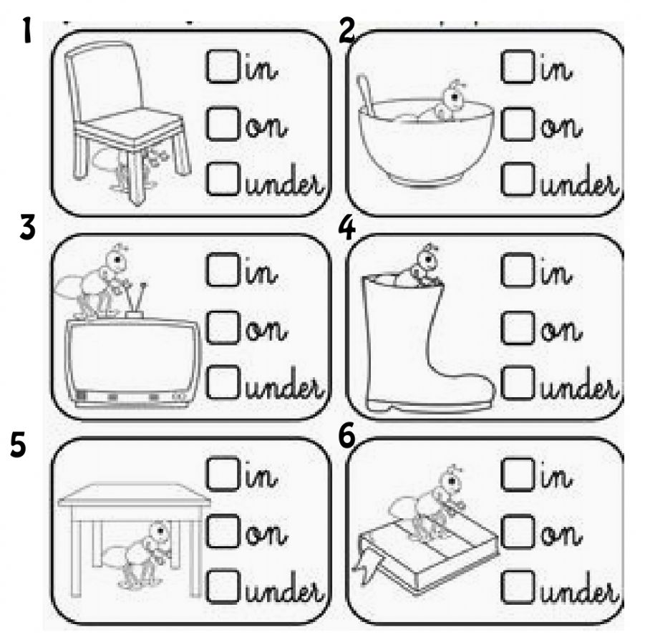

4)Circle the correct position
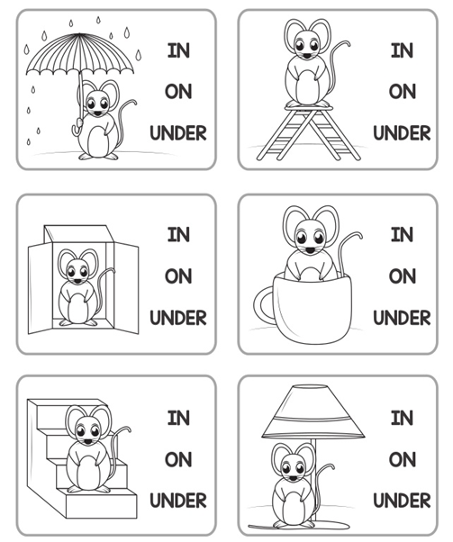

5)Near and Far(ಹತ್ತಿರ ಮತ್ತು ದೂರ)
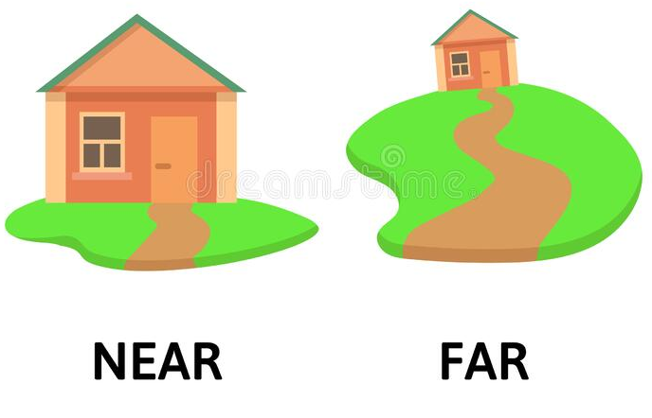
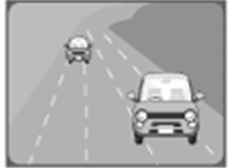
a)Circle the house which is near b) Circle the car which is far
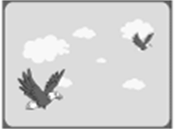
c) Circle the boat which is far d) Circle the bird which is near
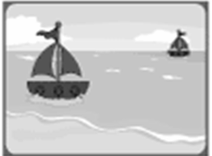
e) Circle the camel which is near f) Circle the tree which is far
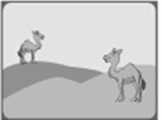

6) Color the animal near to the tree
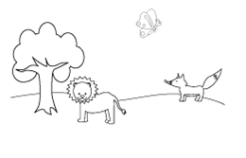
Above and Below(ಮೇಲೆ : ಕೆಳಗೆ)
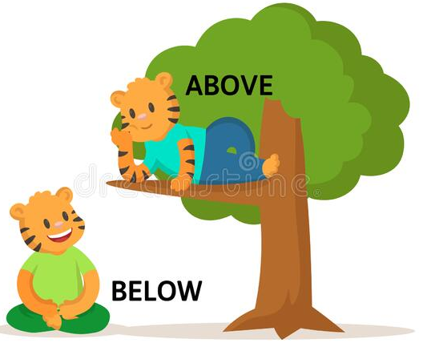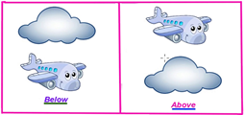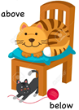

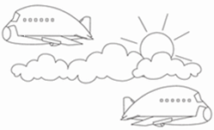
7)Colour which is above

8)Where is the object?
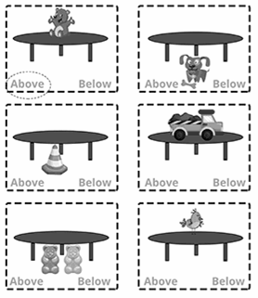

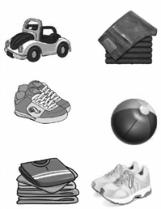

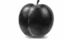
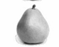

TOP BOTTOM

