Grade

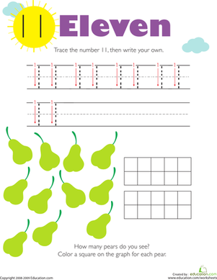

**How many pears do you see………**

**Color a square on the graph for each pear.**

**Trace the number 11. Then write your own.**

**Trace the number 11. Then write your own.**



Sri Sarada Devi Vidya Kendra

DATE:

DAY 1

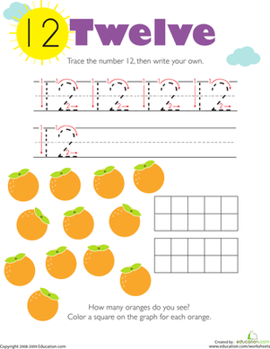

**Trace the number 12. Then write your own.**

**How many Oranges do you see………**

**Color a square on the graph for each orange.**



Sri Sarada Devi Vidya Kendra

DATE:

DAY 1

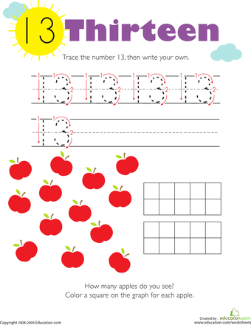

**Trace the number 13. Then write your own.**

**How many apples do you see………**

**Color a square on the graph for each apple.**



Sri Sarada Devi Vidya Kendra

DATE:

DAY 2

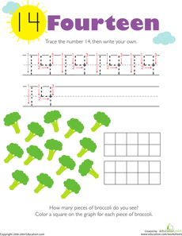

**How many trees do you see………**

**Color a square on the graph for each tree.**

**Trace the number 14. Then write your own.**



Sri Sarada Devi Vidya Kendra

DATE:

DAY 2

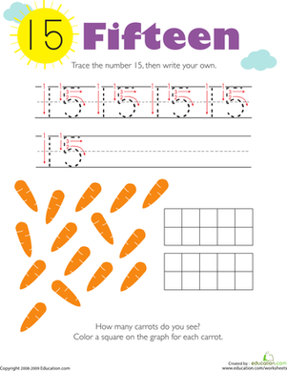

**Trace the number 15. Then write your own.**

**How many carrots do you see………**

**Color a square on the graph for each carrot.**



Sri Sarada Devi Vidya Kendra

DATE:

DAY 3

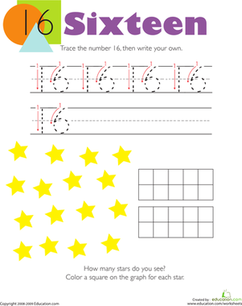

**How many stars do you see………**

**Color a square on the graph for each star.**

**Trace the number 16. Then write your own.**



Sri Sarada Devi Vidya Kendra

DATE:

DAY 3

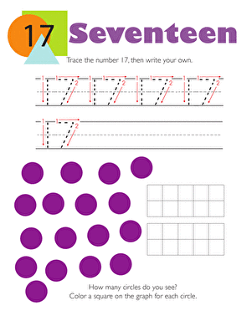

**How many circles do you see………**

**Color a square on the graph for each circle.**

**Trace the number 17. Then write your own.**



Sri Sarada Devi Vidya Kendra

DATE:

DAY 4

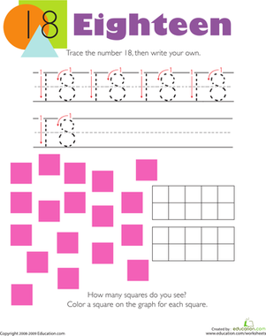

**Trace the number 18. Then write your own.**

**How many Squares do you see………**

**Color a square on the graph for each square.**



Sri Sarada Devi Vidya Kendra

DATE:

DAY 4

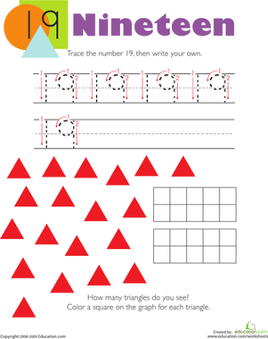

**How many Triangles do you see………**

**Color a square on the graph for each triangle.**

**Trace the number 19. Then write your own.**



Sri Sarada Devi Vidya Kendra

DATE:

DAY 5

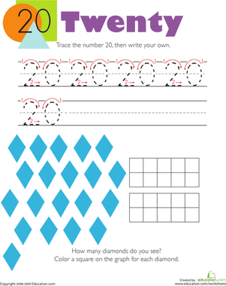

**Trace the number 20. Then write your own.**

**How many Diamonds do you see………**

**Color a square on the graph for each diamond.**



Sri Sarada Devi Vidya Kendra

DATE:

DAY 5