DAY 1 ^{Sri Sarada Devi Vidya Kendra} DATE: Grade
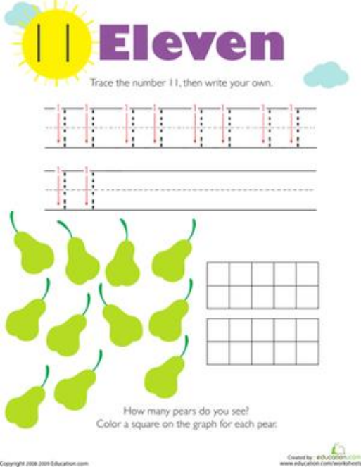Trace the number 11. Then write your own.
Trace the number 11. Then write your own.
How many pears do you see……… Color a square on the graph for each pear.
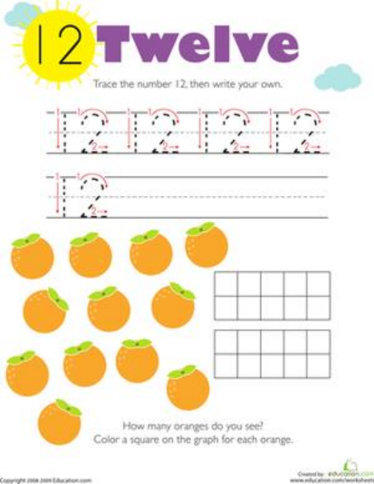
DAY 1 ^{Sri Sarada Devi Vidya Kendra} DATE: Trace the number 12. Then write your own.
How many Oranges do you see………
Color a square on the graph for each orange.
DAY 2 ^{Sri Sarada Devi Vidya Kendra} DATE: Trace the number 13. Then write your own.
How many apples do you see………
Color a square on the graph for each apple.
DAY 2 ^{Sri Sarada Devi Vidya Kendra} DATE:
Trace the number 14. Then write your own.
How many trees do you see……… Color a square on the graph for each tree.
DAY 3 ^{Sri Sarada Devi Vidya Kendra} DATE: Trace the number 15. Then write your own.
How many carrots do you see………
Color a square on the graph for each carrot.
DAY 3 ^{Sri Sarada Devi Vidya Kendra} DATE:
Trace the number 16. Then write your own.
How many stars do you see……… Color a square on the graph for each star.
DAY 4 ^{Sri Sarada Devi Vidya Kendra} DATE:
Trace the number 17. Then write your own.
How many circles do you see……… Color a square on the graph for each circle.
DAY 4 ^{Sri Sarada Devi Vidya Kendra} DATE: Trace the number 18. Then write your own.
How many Squares do you see………
Color a square on the graph for each square.
DAY 5 ^{Sri Sarada Devi Vidya Kendra} DATE:
Trace the number 19. Then write your own.
How many Triangles do you see……… Color a square on the graph for each triangle.
DAY 5 ^{Sri Sarada Devi Vidya Kendra} DATE: Trace the number 20. Then write your own.
How many Diamonds do you see………
Color a square on the graph for each diamond.

