SRI SARADA DEVI VIDYA KENDRA
SHIVANAHALLI
MATHEMATICS
Class: 1
Topic: Group of 10 and More or Less DATE:
DAY 1
1. Look at these. A Bundle of Ten:
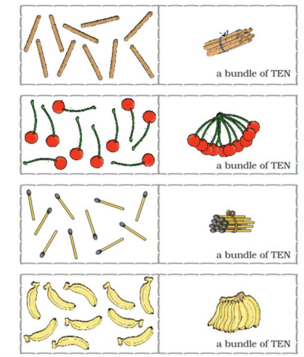
SRI SARADA DEVI VIDYA KENDRA
SHIVANAHALLI
2. Make a group of 1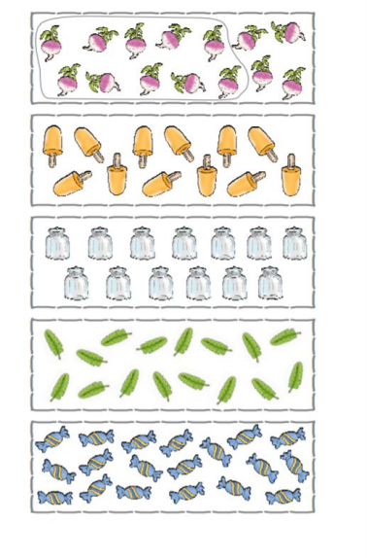0:

SRI SARADA DEVI VIDYA KENDRA
SHIVANAHALLI
DAY 2 DATE: Make a group of 10 and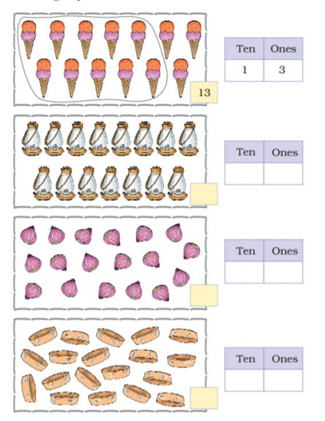 write numbers:

SRI SARADA DEVI VIDYA KENDRA
SHIVANAHALLI
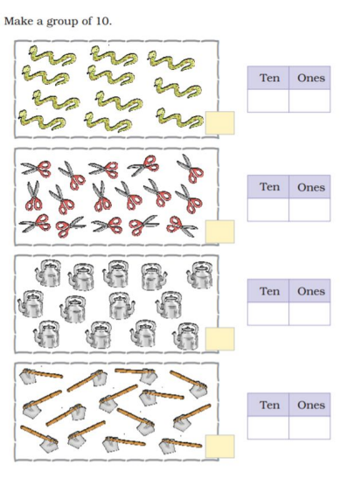
SRI SARADA DEVI VIDYA KENDRA
SHIVANAHALLI
DAY 3 DATE: MORE AND LESS
SRI SARADA DEVI VIDYA KENDRA
SHIVANAHALLI
Tick the group with MORE objects:
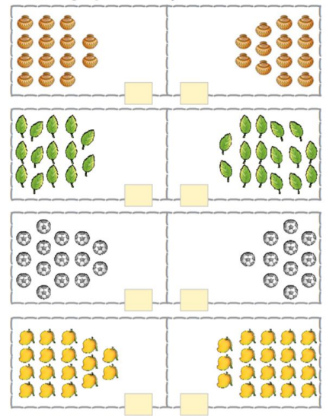
1.
2.
3.
4.
SRI SARADA DEVI VIDYA KENDRA
SHIVANAHALLI
Colour the group with LESS things
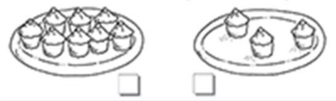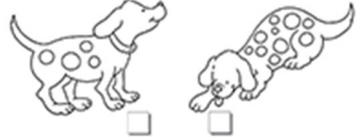
SRI SARADA DEVI VIDYA KENDRA
SHIVANAHALLI
DAY 4 DATE: Draw MORE balls
LESS MORE
Draw LESS caps
MORE LESS
Draw MORE birds.
SRI SARADA DEVI VIDYA KENDRA
SHIVANAHALLI
MORE LESS
Draw MORE leaves.
MORE LESS
Draw LESS mugs.
MORE LESS
SRI SARADA DEVI VIDYA KENDRA
SHIVANAHALLI
DAY 5 DATE: Draw the given things in proper box

