Mathematics
Class: I
Topic: Revision Date:

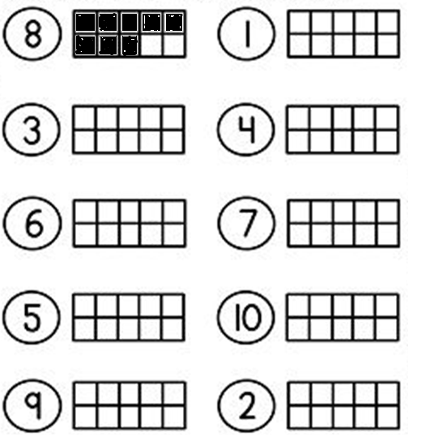
- Look at the numbers. Fill the boxes:

- Find the number of ONES:

14 0nes

____________

____________

____________

____________

- Find the number of tens and ones:

14
1 ten and 4 ones

________________________

________________________

_______________________

________________________

- Fill in the blanks:

- 9, ____, 11, 12, ____, 14, 15.

- _____, ____, 15, ____, 17, 18.

- What comes before 7? ____, 7.

- What comes before 11? ____, 11.

- What comes before 15? ____, 15.

- What comes after 2? 2, ____.

- What comes after 19? 19, ____.

- Draw more or less
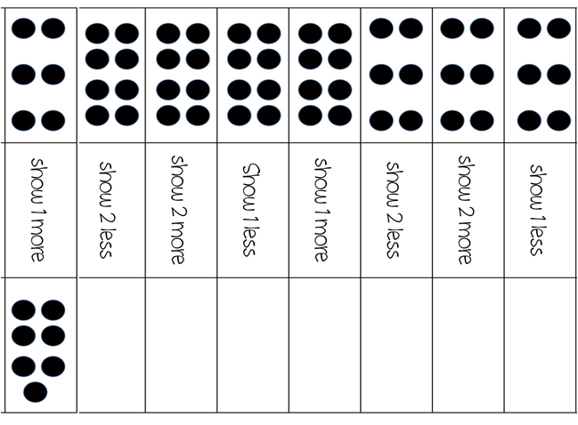

2 more

2 less

1 less

2 less

3 less

3 more

1 more

4 more

- Count backwards:

20, 19, ____, ____, 16, ____, ____, ____,

12, ____, ____, ____, ____, 7, ____, ____,

____, 3, ____, 1.

- Fill in the box:
6
- 1 more than 5 is

- 1 more than 16 is

- 2 more than 8 is

- 5 more than 6 is

- 2 less than 5 is

- 1 less than 17 is

- Learn the number names from 1 to 10:

One - 1
Two - 2
Three - 3
Four - 4
Five - 5
Six - 6
Seven - 7
Eight - 8
Nine - 9
Ten - 10

