Activity Booklet

Class: 2

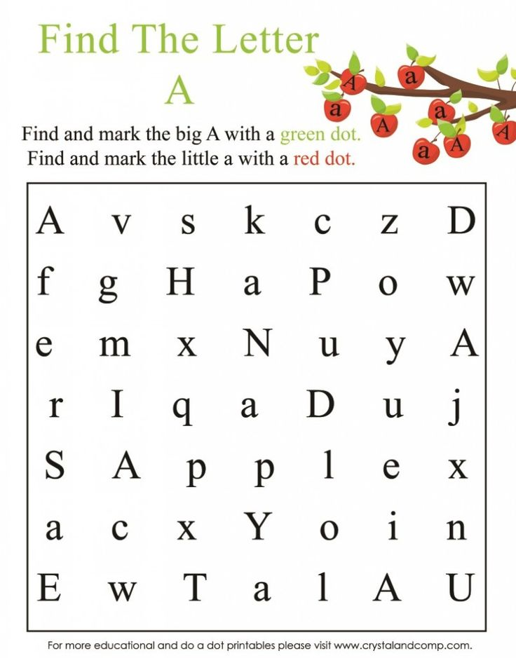

ಸೂಚನೆ:

1. ಮೇಲಿನ ಚಿತ್ರದಲ್ಲಿ A ಹುಡುಕಿ, ಅದರ ಪಕ್ಕದಲ್ಲಿ ಹಸಿರು ಚುಕ್ಕಿ ಇಡು. a ಹುಡುಕಿ ಅದರ ಪಕ್ಕ ಕೆಂಪು ಚುಕ್ಕಿ ಇಡು.

2. ಮುಂದಿನ ಪುಟಗಳಲ್ಲಿ ಕೊಟ್ಟಿರುವ ಅಕ್ಷರ ನೋಡು. ಅದರ ಉಚ್ಚಾರ ತಿಳಿದುಕೊ. ಆ ಅಕ್ಷರವಿರುವ ಇಂಗ್ಲೀಷ ಪದ ಓದು. ನಾಲ್ಕು ಗೆರೆಗಳಿರುವ ಜಾಗದಲ್ಲಿ ಆ ಪದ ಬರೆ.

|  |  |  |
| --- | --- | --- |
| C:\Documents and Settings\Admin\Desktop\A-Z NEW\Aa.jpg  C:\Documents and Settings\Admin\Desktop\IMP English Bridge course booklets March2017\English Alphabets 4 lines\tracing_alphabet_a_0.jpg  A is pronounced as ಆ್ಯ | Apple  C:\Documents and Settings\Admin\Desktop\A-Z NEW\apple.jpgC:\Documents and Settings\Admin\Desktop\A-Z NEW\ant.jpg ant |  |
|  |
| C:\Documents and Settings\Admin\Desktop\A-Z NEW\Bb.jpg  C:\Documents and Settings\Admin\Desktop\IMP English Bridge course booklets March2017\English Alphabets 4 lines\tracing_alphabet_b_0.jpg  B is pronounced as ಬ್ | C:\Documents and Settings\Admin\Desktop\A-Z NEW\bag.jpg  bag  C:\Documents and Settings\Admin\Desktop\A-Z NEW\bus.png  bus |  |
|  |
| C:\Documents and Settings\Admin\Desktop\IMP English Bridge course booklets March2017\English Alphabets 4 lines\tracing_alphabet_c_0.jpgC:\Documents and Settings\Admin\Desktop\A-Z NEW\Cc.jpg  C is pronounced as ಕ್ | C:\Documents and Settings\Admin\Desktop\A-Z NEW\CAT.gif  cat  C:\Documents and Settings\Admin\Desktop\A-Z NEW\car.png  car |  |
|  |

|  |  |  |
| --- | --- | --- |
| C:\Documents and Settings\Admin\Desktop\IMP English Bridge course booklets March2017\English Alphabets 4 lines\tracing_alphabet_d_0.jpgC:\Documents and Settings\Admin\Desktop\A-Z NEW\Dd.jpg    D is pronunced as ಡ್ | C:\Documents and Settings\Admin\Desktop\A-Z NEW\DOG.png  dog    doctor |  |
|  |
| C:\Documents and Settings\Admin\Desktop\IMP English Bridge course booklets March2017\English Alphabets 4 lines\tracing_alphabet_e_0.jpg  C:\Documents and Settings\Admin\Desktop\A-Z NEW\Ee.jpgE is sometimes pronounced as ಎ | Image result for egg BLACK AND WHITE IMAGES  eggs  C:\Documents and Settings\Admin\Desktop\A-Z NEW\engine.jpg  engine |  |
|  |
| C:\Documents and Settings\Admin\Desktop\IMP English Bridge course booklets March2017\English Alphabets 4 lines\tracing_alphabet_f_0.jpgC:\Documents and Settings\Admin\Desktop\A-Z NEW\Ff.jpg  F is pronounces as ಫ್ | C:\Documents and Settings\Admin\Desktop\A-Z NEW\fish.png  fish  C:\Documents and Settings\Admin\Desktop\fan.jpg    fan |  |
|  |
| C:\Documents and Settings\Admin\Desktop\IMP English Bridge course booklets March2017\English Alphabets 4 lines\tracing_alphabet_g_0.jpgC:\Documents and Settings\Admin\Desktop\A-Z NEW\Gg.jpg  Most of the times G is  pronounced as ಗ್ | C:\Documents and Settings\Admin\Desktop\A-Z NEW\black-iron-gate-isolated-white-41856775.jpg  gate  C:\Documents and Settings\Admin\Desktop\A-Z NEW\girl.png  girl |  |
|  |
| C:\Documents and Settings\Admin\Desktop\A-Z NEW\Hh.png  C:\Documents and Settings\Admin\Desktop\IMP English Bridge course booklets March2017\English Alphabets 4 lines\tracing_alphabet_h_0.jpg  H is pronounced as ಹ್ | hen    hut |  |
|  |
| C:\Documents and Settings\Admin\Desktop\i letter class 2 booklet.png  C:\Documents and Settings\Admin\Desktop\IMP English Bridge course booklets March2017\English Alphabets 4 lines\tracing_alphabet_i_0.jpg  I is sometimes pronounced as ಐ | ink  https://i2.wp.com/a.ctimg.net/d36lU6jYRTy7qIuQZC5SUQ/thatte-idli-recipe-soft-idli-recipe-karnataka-special-recipes.1024x1024.jpg?w=1080&ssl=1  idly |  |
|  |
| C:\Documents and Settings\Admin\Desktop\IMP English Bridge course booklets March2017\English Alphabets 4 lines\tracing_alphabet_j_us_0.jpgC:\Documents and Settings\Admin\Desktop\A-Z NEW\Ji.png  J is sometimes pronounced as ಜ್ | juice    jeans |  |
|  |
| C:\Documents and Settings\Admin\Desktop\A-Z NEW\kK.png  C:\Documents and Settings\Admin\Desktop\IMP English Bridge course booklets March2017\English Alphabets 4 lines\tracing_alphabet_k_0.jpg  K is pronounced as ಕ್ | key    king |  |
|  |
| C:\Documents and Settings\Admin\Desktop\A-Z NEW\Ll.png    C:\Documents and Settings\Admin\Desktop\IMP English Bridge course booklets March2017\English Alphabets 4 lines\tracing_alphabet_l_0.jpg  L is pronounced as ಲ್ | lines    leg |  |
|  |
| C:\Documents and Settings\Admin\Desktop\A-Z NEW\Mm 1.pngC:\Documents and Settings\Admin\Desktop\IMP English Bridge course booklets March2017\English Alphabets 4 lines\tracing_alphabet_m_0.jpg    M is pronounced as ಮ್ | C:\Users\AIO\Desktop\plastic-mug-250x250.jpg mug  C:\Users\AIO\Desktop\mango.jpg    mango |  |
|  |
| C:\Documents and Settings\Admin\Desktop\IMP English Bridge course booklets March2017\English Alphabets 4 lines\tracing_alphabet_n_0.jpg  C:\Documents and Settings\Admin\Desktop\A-Z NEW\Nn.png  N is pronounced as ನ್ | net  C:\Users\AIO\Desktop\9.png  nine |  |
|  |
| C:\Documents and Settings\Admin\Desktop\A-Z NEW\Oo.jpg  C:\Documents and Settings\Admin\Desktop\IMP English Bridge course booklets March2017\English Alphabets 4 lines\tracing_alphabet_o_0.jpg    O is pronounced as ಆ | onion    oil |  |
|  |

|  |  |  |
| --- | --- | --- |
| C:\Documents and Settings\Admin\Desktop\A-Z NEW\Pp.png      C:\Documents and Settings\Admin\Desktop\IMP English Bridge course booklets March2017\English Alphabets 4 lines\tracing_alphabet_p_0.jpg  P is pronounced as ಪ್ | pen    pot |  |
|  |
| C:\Documents and Settings\Admin\Desktop\IMP English Bridge course booklets March2017\English Alphabets 4 lines\tracing_alphabet_q_0.jpg  C:\Documents and Settings\Admin\Desktop\A-Z NEW\Qq.jpg  Q is pronounced as ಕ್ವ್ | question    queen |  |
|  |
| C:\Documents and Settings\Admin\Desktop\A-Z NEW\Rr.jpg  C:\Documents and Settings\Admin\Desktop\IMP English Bridge course booklets March2017\English Alphabets 4 lines\alphabet_tracing_robot_460_0.jpg  R is pronounced as ರ್ | ring  roof |  |
|  |
| C:\Documents and Settings\Admin\Desktop\A-Z NEW\Ss.jpg    C:\Documents and Settings\Admin\Desktop\IMP English Bridge course booklets March2017\English Alphabets 4 lines\tracing_alphabet_s_0.jpg  S is pronounced as ಸ್ | sun    soap |  |
|  |
| C:\Documents and Settings\Admin\Desktop\IMP English Bridge course booklets March2017\English Alphabets 4 lines\tracing_alphabet_t_0.jpg  C:\Documents and Settings\Admin\Desktop\A-Z NEW\Tt.png    T is pronounced as ಟ್ | tap    tomato |  |
|  |
| C:\Documents and Settings\Admin\Desktop\A-Z NEW\Uu 1.png    C:\Documents and Settings\Admin\Desktop\IMP English Bridge course booklets March2017\English Alphabets 4 lines\tracing_alphabet_u_0.jpg  U is pronounced as ಅ | Image result for umbrella black and white images  umbrella    The cat is **under** the tree.  Under |  |
|  |

|  |  |  |
| --- | --- | --- |
| C:\Documents and Settings\Admin\Desktop\IMP English Bridge course booklets March2017\English Alphabets 4 lines\tracing_alphabet_v_0.jpgC:\Documents and Settings\Admin\Desktop\A-Z NEW\vV.png    V is pronounced as ವ್ | van    vessel |  |
|  |
| C:\Documents and Settings\Admin\Desktop\IMP English Bridge course booklets March2017\English Alphabets 4 lines\tracing_alphabet_w_0.jpg  W is pronounced as ವ್ | wash    water |  |
|  |
| C:\Documents and Settings\Admin\Desktop\A-Z NEW\Xx.png  C:\Documents and Settings\Admin\Desktop\IMP English Bridge course booklets March2017\English Alphabets 4 lines\tracing_alphabet_x_0.jpg  X is pronounced as ಕ್ಸ್ | fo**x**    ta**x**i |  |
|  |
| C:\Documents and Settings\Admin\Desktop\IMP English Bridge course booklets March2017\English Alphabets 4 lines\tracing_alphabet_y_0.jpgC:\Documents and Settings\Admin\Desktop\A-Z NEW\Yy.png    Y is pronounced as ಯ್ | yoga |  |
|  |
| C:\Documents and Settings\Admin\Desktop\A-Z NEW\Zz.png  C:\Documents and Settings\Admin\Desktop\IMP English Bridge course booklets March2017\English Alphabets 4 lines\tracing_alphabet_z_0.jpg  Z is pronounced as | zoo    zip |  |
|  |

