English
Class: 2
Week 10
1.11.2020 – 7.11.2020
Start at the star and practice writing letters.
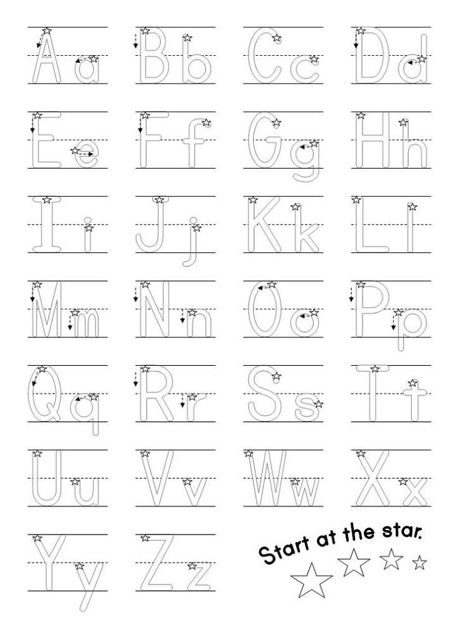
Write ABCD… and abcd once every day telling it aloud.
ಬಾಯಲ್ಲಿ ಹೇಳಿಕೊಂಡು ದಿನಕ್ಕೊಂದು ಬಾರಿ ABCD….ಮತ್ತು a b c d ಬರೆ.
.
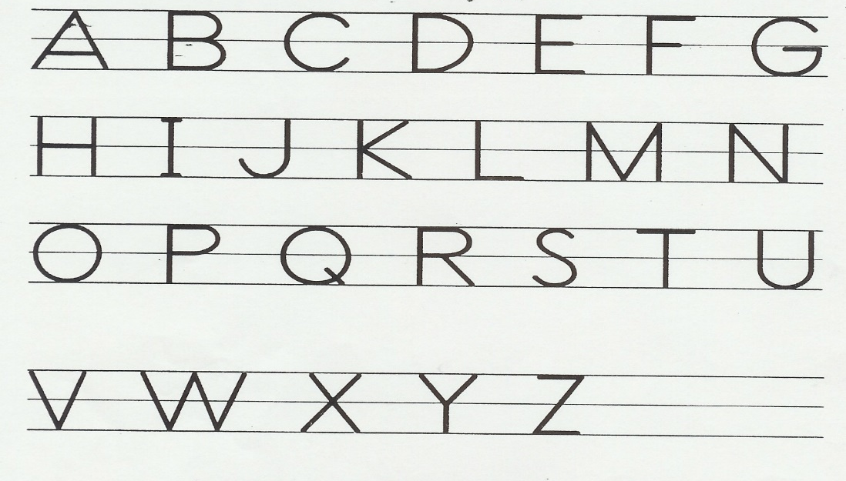

Look at the word. If you know the word read and complete the table. If not, listen to the word in the Week 10 audio. Say the word 4 times. W rite the word four times.
ಚಿತ್ರ ನೋಡು. ಪದ ಗೊತ್ತಿದ್ದರೆ ಅದನ್ನು ಓದು. ಇಲ್ಲದಿದ್ದರೆ, 10ನೇ ವಾರದ ಆಡಿಯೋದಲ್ಲಿ ಪದ ಕೇಳಿಸಿಕೊ. ಪದವನ್ನು ೪ ಸಲ ಜೋರಾಗಿ ಹೇಳು. ಪದವನ್ನು ಹೇಳಿಕೊಂಡು 4 ಸಲ ಬರೆ.

Picture | Word | Write the word | Write the word
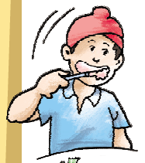 | brush
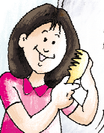 | comb
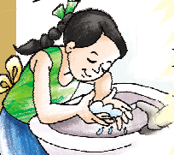 | wash
 | pen
 | pencil
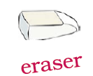 | eraser

Listen to the poem. Learn this poem by heart.

Listen to the poem and read. Listen until you know it by heart.
Your legs know how to run
Your eyes know how to smile
Your mouth knows how to scream 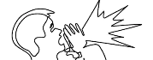
Your heart knows how to love. 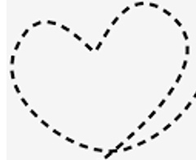

Listen to the following using the audio.

Smile | When I am happy, I smile.
When I am sad, I cry. | Cry
Write your name here: | I am ______.  (your name)
I am ___ years old.  (Write your age here.) | Draw/paste your photo.

Make sentences to describe yourself. Start the sentence like this: I am __________.
Example: 1. I am Asha.
2. I am 5 years old.

1.___________________________________________________________________.

2.___________________________________________________________________.

3,____________________________________________________________________.

4.____________________________________________________________________.

5.____________________________________________________________________.

