Mathematics
Class: 2 Topic: 12
Shapes around us II Date: 18.11.2020

- You have traced objects last week.
Look at this object.

This is a bottle. Trace the outline of the bottle.

bottle
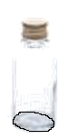

Now, you collect 5 things (ವಸ್ತು), like pencil box, toy (ಆಟದ ಸಾಮಾನು), bowl(ಬಟ್ಟಲು), leaf(ಎಲೆ), matchbox (ಬೆಂಕಿ ಪೆಟ್ಟಿಗೆ), coin (ಹಣ) or anything you like:
Trace the shape of each object from different sides: (ಒಂದೇ ವಸ್ತುವಿನ ಆಕಾರವನ್ನು ಬೇರೆ ಬೇರೆ ಕಡೆಯಿಂದ ಟ್ರೇಸ್ ಮಾಡಿ).
Trace here. Write the name of the things.

- Match the object and the shape:

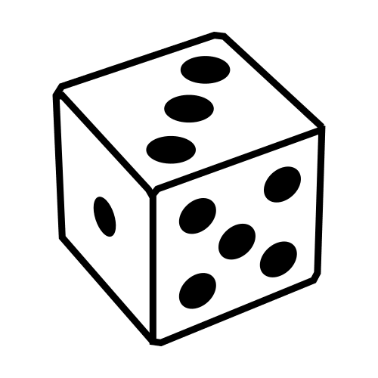

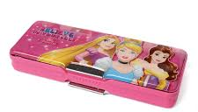

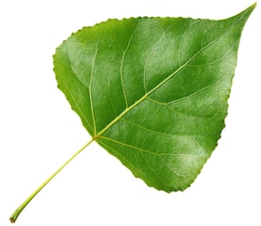

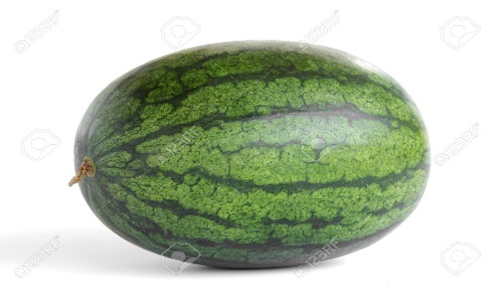

- Look at the box.
Draw the shape of the numbered side. (audio)
e.g:
Side 1
Side 2
1

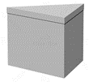
1
2
3
2

Side 1
Side 2
Side 3

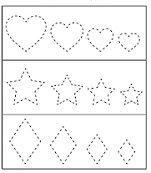
- Trace the shapes
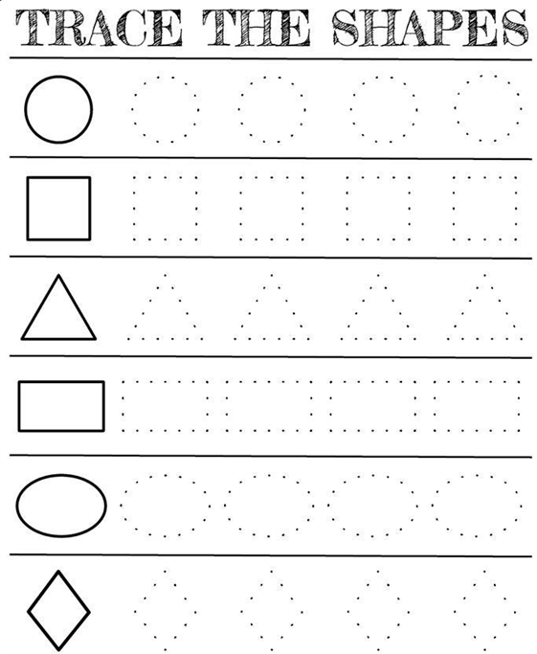

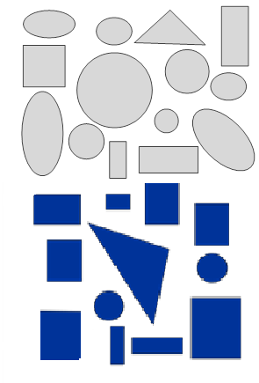
- How many in each shape?

- How many ? ________.

- How many ? ________.

- How many ? ________.

- How many ? ________.

