English

Making of a story

Make up your own story by using the words from the short “U” word bank to fill in the blanks in the story. You may use the same word more than once.
“Short U” Puzzle Word Bank
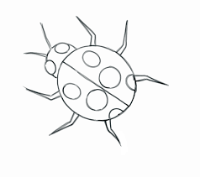 | 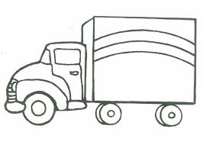 | 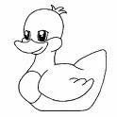 | 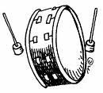
bug | truck | duck | drum
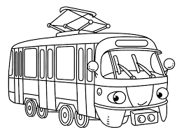 | 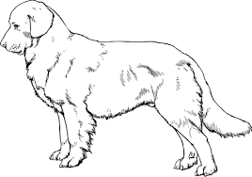
bus | puppy | cup | umbrella

The Picnic

A ____________________ and a ________________had a picnic.
They ate lots of food, and played with a ___________________ and a _____________. A____________came by and they all ran to the ________________.

Raja Story
Raja called Shyama to come and play with him. Shyama said that he had to work and could not play. | 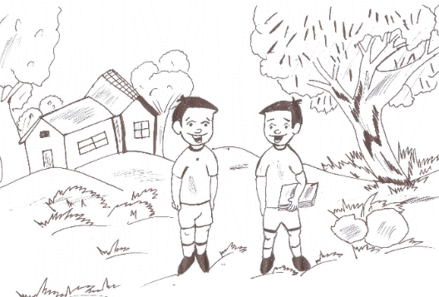
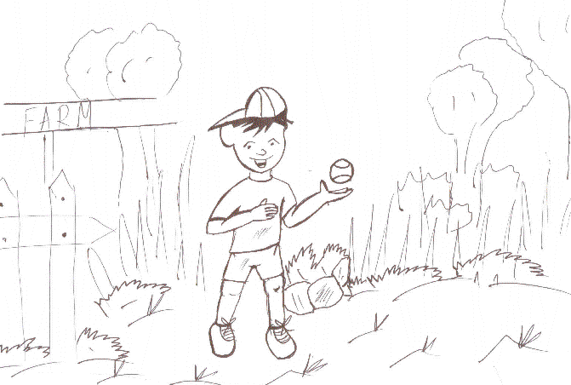 | Raja went to a field with a ball.
Raja saw honey bees and called them to play. Honey bees said they could not play as they had to work. | 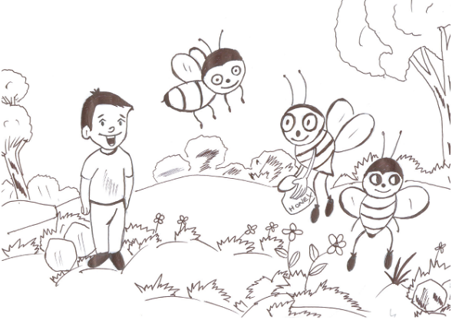
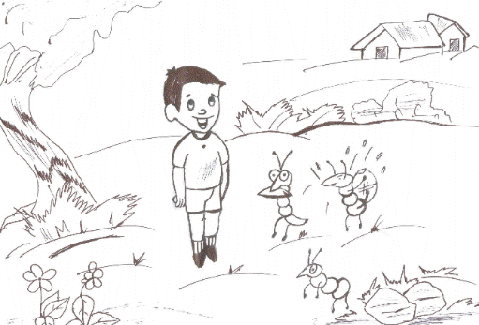 | He then saw ants. Raja called out, “Ants! Ants! Come let us play!”. “No, we cannot play. We have to work,” said the ants.
Raja went home. He helped his father at work. Father said, “You are a good boy”. Raja felt happy. | 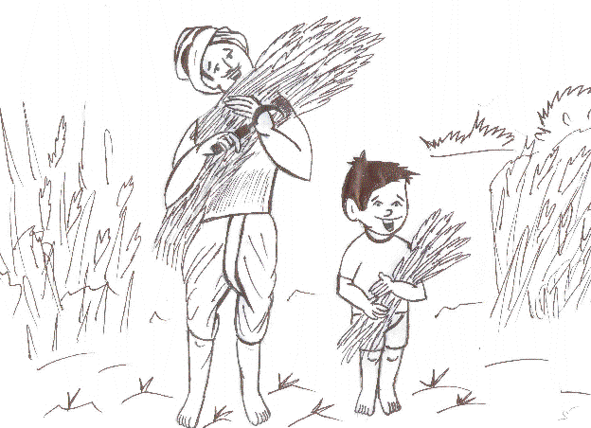

Read the following sentences. Understand them. Write them in the correct order.
Raja called ants to play.
Raja called Shyama to play.
Raja called honeybees to play.

Why did Shyama not play with Raja?

What work did Raja’s father do?
1)farm work 2) factory work 3) school work

Poem:
Hop a little, jump a little
one, two, three
Run a little, skip a little
tap one knee
Bend a little, stretch a little
nod your head
Yawn a little, sleep a little
in your bed.

Choose the rhyming words from the bracket, write it nest to the word. Try to make a sentence using both the words.
Example
boy, (ball, joy)
Rhyming words - boy, joy
Sentence: The boy jumped with joy.
box, (fat, fox)

late, (gate, game)

house, (mice, mouse)

mend, (bind, bend)

sow, (bow, box)

