English – Week 15
Name:
Class:
Village:
Date:
Look at the pictures below. Say the words. They all have letter ‘I’ in them with ʼಇʼ sound. Example: fish.
Make sentences using each of these words.
Example: Word: Pin; Sentence: I have a pin.
Word: Sing; Sentence: I like to sing bhajans.

 |  |  | 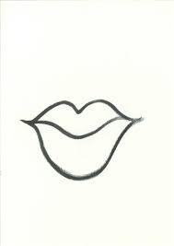  ` | 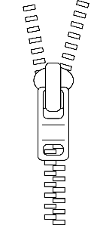
fish | pig | pin | lips | zip
 |  | 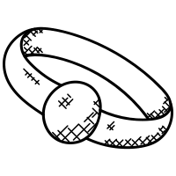
slippers | swim | ring | sing | pills

Read the story.
A HOUSE FOR A MOUSE
A mouse is looking for a house. | 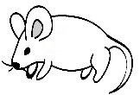
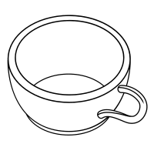 | A cup is too small.
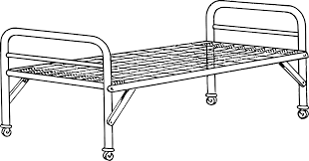 | A cot is too big.`
TV is too noisy
 | A fan is too cold.
A bucket is too wet.
 | The stove is too hot.
Under the cupboard is a good house for mouse.
It is not too small. It is not too big.
It’s not too noisy.
It’s not too cold. Its not too hot.
Its not too wet. It is a good house for a mouse.
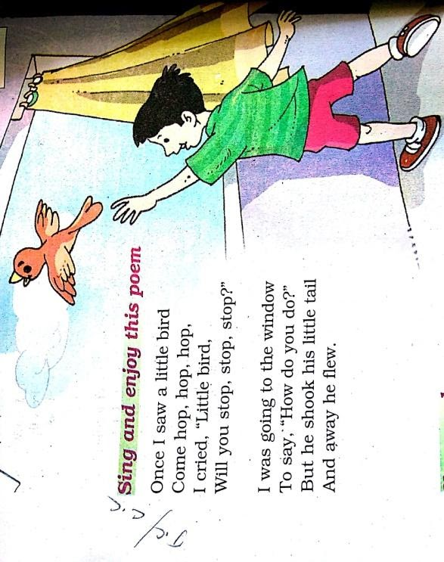

Find the rhyming words and underline them.

1. hop, stop, _______(pop, peep)
2. good, stood _______(pen, food)
3. pole, role ________(hole, went)
4. fan, man ________(left, ran)
5. pad, mad _______(seed, sad)
6. pot, lot _______(not, rabbit)
7. come, some, _________ (go, gum)
8.flew, blue, ___________ (fly, chew)

Read the following sentences. Understand the sentences. Draw pictures from what you understand.
There is a cup on the table.

This mouse has a long tail.

There is a bucket under the tap

There are two doors and one window in that house.

I am a rabbit. Please label my parts. You can look for the words below.
