MATHEMATICS
Class: 2
Topic: Shapes chapter 13

1)Using match sticks (ಬೆಂಕಿಕಡ್ಡಿಗಳು) or sticks (ಕಡ್ಡಿ) create your own shapes and paste.
- Using 3 sticks

- Using 4 sticks

- Using 5 sticks

2) Do questions from textbook page no: 44,45
3)Colour Blue Yellow Green Red

4)Shape names (listen to audio and learn)
CIRCLE RECTANGLE

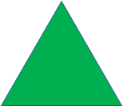
SQUARE TRIANGLE

5) Write and practice (Learn spellings)

