Mathematics
Class: 3
Topic: Numbers - Revision Date:

- Write the value of the underlined digit:

- 5 8 = 8 ones

- 3 5 = _____________________

- 1 2 5 = _____________________

- 9 9 = _____________________

- 3 4 9 = _____________________

- 2 1 7 = _____________________

- Match the underlined digit with its value:

304 | Four hundreds
217 | Four tens
645 | Four ones
186 | One tens
445 | One hundred

- How many ONES?

44 ones

________

- Find the number of tens and ones:
4 tens and 4 ones = 44

- Fill in the blanks:

- 49, ____, 51, 52, ____, 54, 55.

- _____, ____, 75, ____, 77, 78.

- What comes before 70? ____, 70.

- What comes before 81? ____, 81.

- What comes before 100? ____, 100.

- What comes after 29? 29, ____.

- What comes after 99? 99, ____.

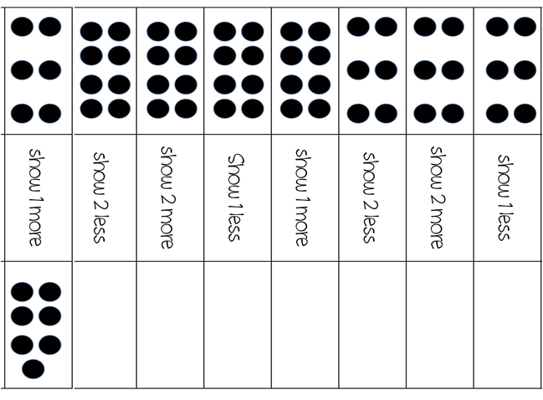
- Draw more or less

2 more

2 less

1 less

2 less

3 less

3 more

1 more

4 more

- Count backwards:

100, 99, ____, ____, 96, ____, ____, ____,

92, ____, ____, ____, ____, 87, ____, ____,

____, 83, ____, 81.

- Fill in the box:
60
- 1 more than 59 is

- 1 more than 36 is

- 2 more than 78 is

- 5 more than 86 is

- 2 less than 95 is

- 1 less than 100 is

- Learn the number names from 20 to 30:

Twenty one - 2 1
Twenty two - 2 2
Twenty three - 2 3
Twenty four - 2 4
Twenty five - 2 5
Twenty six - 2 6
Twenty seven -2 7
Twenty eight - 2 8
Twenty nine - 2 9
Thirty - 3 0

