Mathematics
Class: 3
Topic: Date:
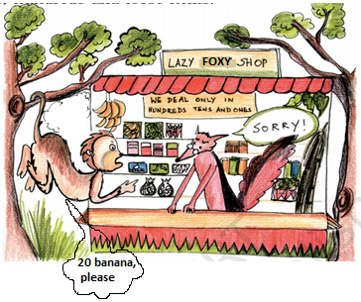
- This is lazy fox’s shop.
He sells food only in hundreds, tens and ones.
Animals buy food in lazy fox shop.

Rabbit needs 143 carrots. How many packets of hundreds, tens and ones of carrots will he buy?
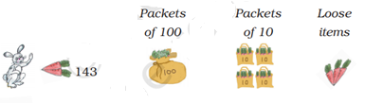

Fill in the blanks:

- Read the names in the table. Find the number in the number chart given below. Circle the correct number.

JUMP AND COUNT:

