Subject: EVS
Class: 4 Water Topic 19
Name: Village:

- Activity: What did you observe? Put ( ) mark in the right places.
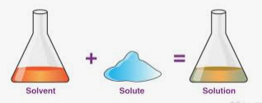

Things | Dissolved (mixed) in water | Did not dissolve in water | Colour of water changes | Colour of water does not change
Sugar
Salt
Lemon juice
Haldi
Soap water
Flour
Dal
Sherbet
Cooking soda
Oil

- Do all things dissolve in water?

- Does the colour of the water always change?

- Did oil dissolve in water? How can you say whether it has dissolved or not?

- Project: Make your own water filter at home.
Material required: 1. One transparent bottle
2. Cotton or clean cloth
3. Coarse sand
4. Fine sand
5. Charcoal
6. Rocks or pebbles
7. Knife
Process: Take one transparent bottle and cut into half and put the materials in the upper part of the bottle as per the picture given below.

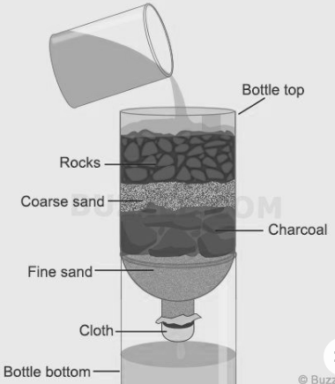

III. Look at the given pictures.

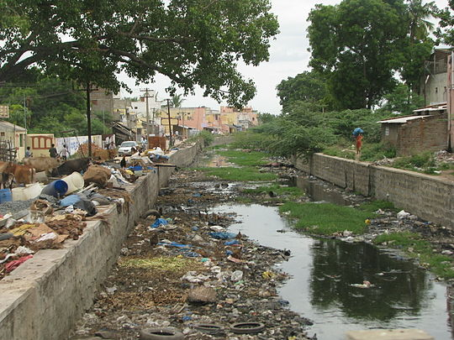
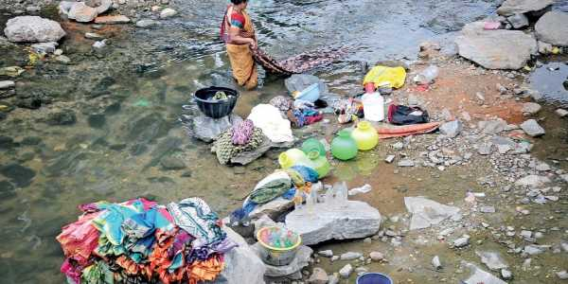
- Write the causes of water pollution.

______________________________________________________________________

______________________________________________________________________

______________________________________________________________________

______________________________________________________________________.

- Which wastes have dissolved in the polluted water body?

- ______________________________________________________________________

- ______________________________________________________________________

- ______________________________________________________________________

3. List the wastes that have not dissolved in the water.

- Make a poster on awareness of water pollution.

