Subject: English
Class: 4 Topic: Revision Date: 4/11/2020
Name:

Day 1:

Colour the pictures.
Write the first letter of the pictures (Both Capital and Small).

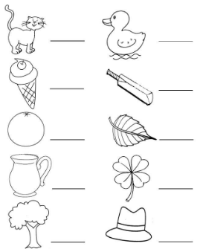
Day 2:

Circle the differences between two pictures.

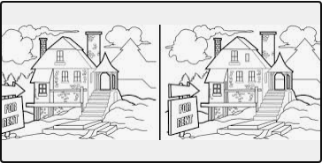

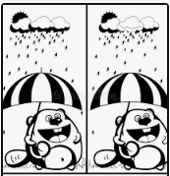
Day 3:

Draw lines to match with the correct body parts.

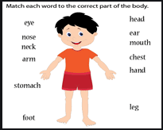

Day 4:

Fill in the missing letters to complete the body parts.

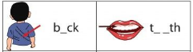

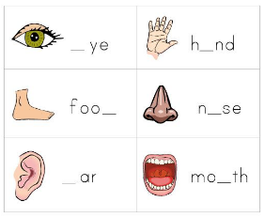

Day 5:

Cut and paste the words that match the correct action for each body part.

