Name:
Class:6 Subject: Science
Sorting of materials into groups Topic: 15

Day 1
- Geetha has the following objects. She finds it difficult to sort(separate) the materials into groups. Can you help her to sort the objects?
Shoes, bottle, watch, comb, chair, bulb, pen, toy, clothes, book, ball, balloon, pot, table, key glass, pencil, ring, cycle, newspaper, car, door, salt, scissor, spoon, bell, bus, bangle, bucket, window, ink bottle, iron, scale, mobile, belt, slipper, chalk piece, eraser, duster, chain, TV, bag, pin, tube light, calendar, bullock cart, computer, cot, bench, plate.

- List five objects and the materials they are made of in the given table. One is done for you.

objects | Materials they are made of
Plate | Steel, glass, plastics

- lists some common materials. You can also add more materials in Column 1 that are known to you. Now, try and think of everyday objects you know, that are made mainly of these materials, and list them in Column 2. One is done for you.

Material | Objects made of these materials
Wood
Paper
Leather
Plastics
Cotton

- classify the objects as eatables or non-eatables.
(sugar, apple, ball, pen, pot, grapes, chocolate)

- Which of these objects are made of wood and which of them are made of paper?
(table, chair, newspaper, calendar, bullock cart, notebook)

- Why do we need to group materials?

- On what basis are the various objects grouped?

Day 2 and Day 3

- Underline the correct description of the picture.

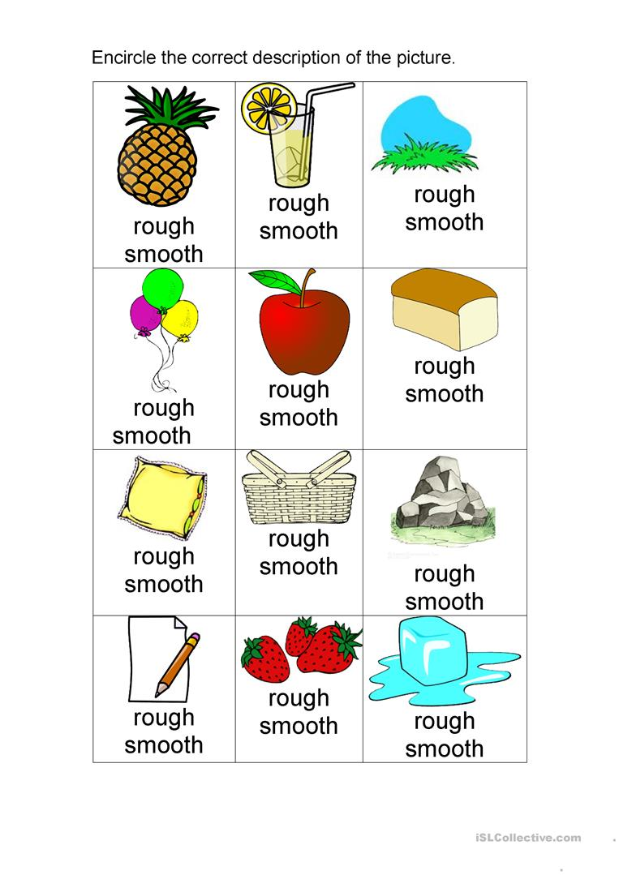

- Identify which object is hard and which is soft

Hard | Soft
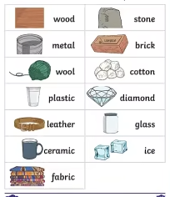

- List out the objects which are hard and soft, rough and smooth in your home.

Rough | Smooth | Hard | Soft
1.

2.

3.

4.

5.

- Collect and paste the things which are hard and soft and rough and smooth.

Hard | Hard
Soft | Soft
Rough | Rough
Smooth | Smooth
Day 4

- Collect soft materials available at your home and make any objects that you like.
Ex: toys, greeting cards etc.

