Subject: English
Class: 7 Topic: Revision Date: 4/11/2020
Name:

Day 1

- Read about Deepika’s house.

Deepika’s house is in the village. It is made of bricks and stones. It is an old house. It has a big veranda. Her mother and father, her grandmother and her two brothers and one sister live in the house. They also have a dog and a cat. There are many books in the house and there are some pictures on the walls. There is a garden behind the house.

Write the answers of the following questions:

- Where is Deepika’s house?

______________________________________________________________________

- What is the house made of?

- How many people live in the house?

______________________________________________________________________

- What animals are in the house?

______________________________________________________________________

- What is behind the house?

________________________________________________________________________

- What is on the walls?

______________________________________________________________________

- Is the veranda big or small?

______________________________________________________________________

- Choose the correct words to complete the word puzzles.

chair mat kitchen clock broom switch bucket bricks

- We tell the time from this. ______________________

- We make walls from this. ______________________

- We put the light on with this. ______________________

- The cooking is done here. ______________________

- We can sit on this. ______________________

- We sweep the floor with this. ______________________

- We can sit or sleep on this. ________________________

- We put water in this. __________________________

Day 2:

Rewrite the sentences with correct capital letters.

- ram went to his native on last monday.

- my friend and i visited lalbagh garden last december.

- my favorite book is krishna kuchela.

- my brother is coming from mumbai by rajdhani express.

- anand went to lakshmi theater to watch googly with his family on friday.

______________________________________________________________________

- we all celebrate diwali with lights and worship goddess lakshmi on that day.

______________________________________________________________________

______________________________________________________________________
Day 3:

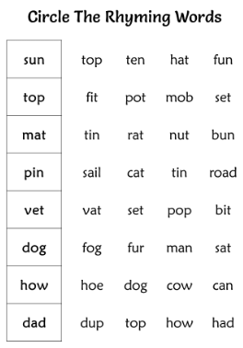

Day 4:

Cut the pictures below and paste them into the correct box.

